NAME: HARSHINI P R REG NO: 192524165
COURSE CODE: CSA0603 COURSE NAME: DAA

LAB PROGRAMS SESSION – 4

1. s = "abbxxxxzzy"
result = []
i = 0
while i < len(s):
j = i
while j < len(s) and s[i] == s[j]:
j += 1
if j - i >= 3:
result.append([i, j - 1])
i = j
print(result)

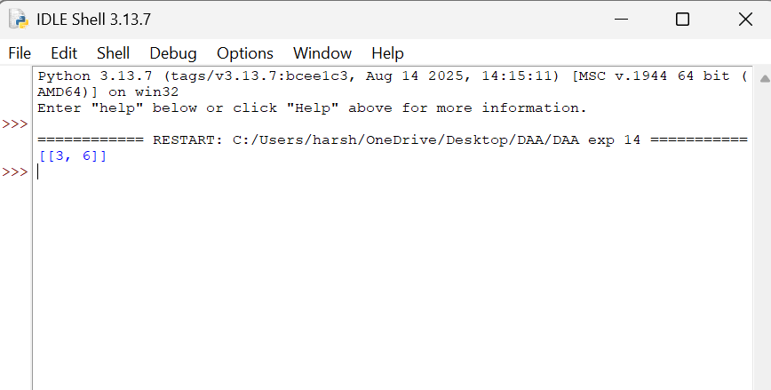
2. board = [[0, 1, 0],
[0, 0, 1],
[1, 1, 1],
[0, 0, 0]]
m = len(board)
n = len(board[0])
new = []
for i in range(m):
row = []
for j in range(n):
count = 0
for x in range(max(0, i-1), min(m, i+2)):
for y in range(max(0, j-1), min(n, j+2)):
if (x, y) != (i, j):
count += board[x][y]
if board[i][j] == 1:
if count == 2 or count == 3:
row.append(1)
else:
row.append(0)
else:
if count == 3:
row.append(1)
else:
row.append(0)
new.append(row)
print(new)

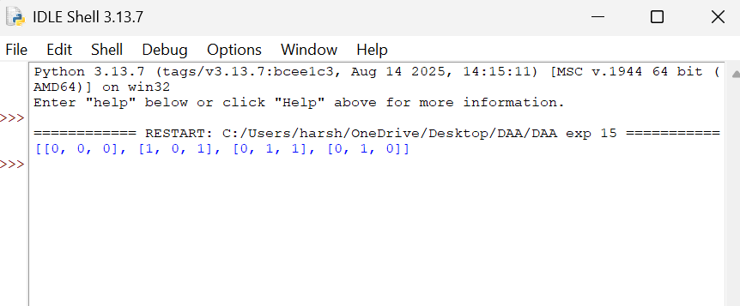
3. poured = 2
query_row = 1
query_glass = 1
glasses = [[0] * 101 for i in range(101)]
glasses[0][0] = poured
for i in range(query_row + 1):
for j in range(i + 1):
if glasses[i][j] > 1:
extra = (glasses[i][j] - 1) / 2
glasses[i + 1][j] += extra
glasses[i + 1][j + 1] += extra
print(min(1, glasses[query_row][query_glass]))
